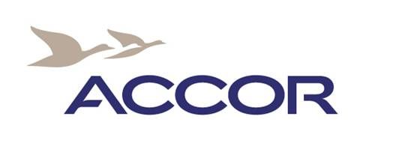
ACCOMMODATION REQUEST FORM
FOR THE 14th INTERNATIONAL CONFERENCE ON FINANCE AND BANKING

A limited block of rooms has been reserved at the hotel Mercure Ostrava Center for 15th - 18th October 2013 and can be booked by participants at special rates on a first come, first served basis:

- Single room accommodation is available for conference participants at EUR 47 per night
- Double room accommodation is available for conference participants at EUR 59 per night

Rates are including breakfast and without VAT (15 %)
Access to the hotel wellness centre (fitness room, steam bath) and Wi-Fi connection is available free of charge for the hotel guests.

CANCELLATION POLICY:
You may cancel the reservation one day prior the arrival without any charges. In case of no show first night will be charged.

Please fill out the table to guarantee your booking and use the contacts below. Thank you very much!

Guest First name: |  | Guest Surname:
Email address: |  | Telephone / fax number:
Arrival Date: |  | Departure Date:
Standard single room  EUR 47 / room | YES/NO | Standard double room  EUR 59 / room  Standard twin room  EUR 59 / room | YES/NO  DBL (1 big bed) or  TWIN (2 separated beds)
Superior single room  EUR 57 / room | YES/NO | Superior twin room  EUR 69 / room | YES/NO  TWIN (2 separated beds)
Transfer from /to the airport Ostrava  CZK 750 (one way) | YES/NO | Transfer from/to the main train station Ostrava  CZK 80 (one way) | YES/NO
Credit card holder:
Type:
Number:
Expiration date:

Hotel Employee’s name:
Confirmation number:
Signature:

